Charlottesville

703 Concord Avenue
Charlottesville, VA 22903
(434) 984-4655 * (434) 984-2803 fax
www.virginia-organizing.org
Sally Bastian
Grassroots Fundraising Coordinator
Harold Folley
Organizer
Michele Mattioli
Special Projects Coordinator
Maggie Murphy
Director of Advancement
Laura Ramirez
Director of Finance & Administration
Joe Szakos
Executive Director
Director of Communications
Amanda Pohl
(804) 337-1912
Database Administrator
Ben Thacker-Gwaltney
(757) 570-3005
Chesapeake/Suffolk
Tuere Brown – Organizer
(757) 281-9798
Fredericksburg
Addie Alexander – Organizer
(434) 249-4058
Rabib Hasan – Organizer
(571) 529-0272
Lynchburg
Haley Wilson – Organizer
(434) 907-6116
New River Valley
Andrae Hash – Organizer
(540) 320-7204
Portsmouth/Eastern Shore
Meghan McNamara – Organizer
(847) 922-1213
Roanoke/Blacksburg
Keith Johnson – Organizer
(540) 443-8965
Shenandoah Valley
Isabel Castillo – Organizer
(540) 830-6023
South Hampton Roads
Teresa Stanley – Organizer
(757) 286-5858
Southside
Nik Belanger – Organizer
(434) 709-4953
Southwest Virginia
Brian Johns – Organizing Director
(276) 619-1920

October 6, 2016
RE: Docket No. CFPB-2016-0025

Richard Cordray, Director
Consumer Financial Protection Bureau
1700 G Street, NW
Washington, D.C. 20552

Dear Director Cordray,

Virginia Organizing, a non-partisan statewide grassroots organization, encourages you to develop the best rule possible for Payday, Vehicle Title, and Certain High-Cost Installment Loans.

Many of our members have submitted individual comments for the proposed rule, so I will focus on just one key point. Please adopt a strong rule that will cover everyone in the country. Why is this important to us? As it now stands, there are 51 different rules for the 50 states and the District of Columbia. And these rules vary dramatically.

We have learned this the hard way in Virginia, where our consumers are often mistreated. If they lived in another state, they would be protected, but in Virginia, they are not.

A strong federal rule will set a baseline of fairness that will provide protections for all consumers, not just for those who happen to live in a particular state. The first-ever federal rule for small-dollar loans can stop the abuses of payday and car title loans that have hurt borrowers for the past 25 years.

Thanks for this opportunity to submit our comments.

Sincerely,
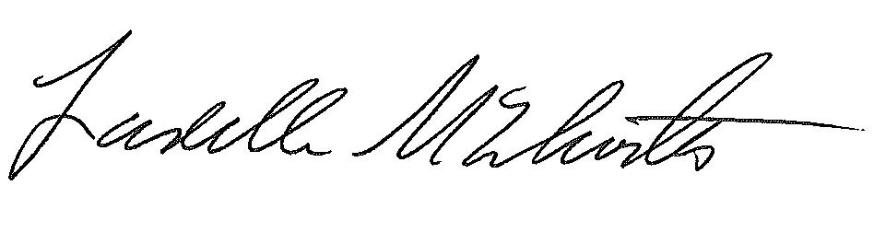
Ladelle McWhorter
Chairperson

